**UNIT-1**

**Data Visualization**: Introduction, A Brief History of Data Visualization, Good Graphics - Scientific Design Choices in Data Visualization, Static Graphics- Complete Plots, Customization, Data Visualization Through Their Graph Representations, High-dimensional Data Visualization, Linked Data Views.

**Introduction:**

Data visualization is the art and science of transforming data into visual contexts, such as charts, graphs, and maps, to make the information easier to understand and interpret. By leveraging visual elements, data visualization helps identify patterns, trends, and outliers within large data sets.

**Key Concepts:**

1. **Types of Visualizations:**
   * **Bar Charts:** Ideal for comparing quantities across categories.
   * **Line Charts:** Excellent for showing trends over time.
   * **Pie Charts:** Useful for displaying parts of a whole.
   * **Histograms:** Show frequency distributions.
   * **Scatter Plots:** Highlight relationships between two variables.
   * **Heatmaps:** Represent data values in a matrix format with varying colors.
2. **Tools and Software:**
   * **Tableau:** A powerful tool for creating interactive and shareable dashboards.
   * **Power BI:** Microsoft's analytics service, providing a wide range of visualizations.
   * **Matplotlib and Seaborn:** Python libraries for creating static, animated, and interactive plots.
   * **D3.js:** A JavaScript library for producing dynamic, interactive data visualizations in web browsers.
3. **Principles of Effective Data Visualization:**
   * **Clarity:** Ensure the visual is easy to read and interpret.
   * **Accuracy:** Represent data truthfully without misleading the audience.
   * **Efficiency:** Communicate the information quickly and effectively.
   * **Aesthetics:** Make the visual appealing without compromising clarity and accuracy.
4. **Applications:**
   * **Business:** For performance tracking, market analysis, and financial reporting.
   * **Healthcare:** To visualize patient data, track disease outbreaks, and analyze medical research.
   * **Science and Engineering:** For experimental data analysis, simulations, and research findings.
   * **Journalism:** To present complex information to the public in an understandable format.

**A Brief History of Data Visualization**

The history of data visualization is quite fascinating and spans several centuries. Here's a brief overview:

**Early Beginnings: Maps and Navigation**

* **Pre-17th Century:** Data visualization primarily existed in the form of maps, which were essential for navigation, trade, and territorial claims. These maps displayed land markers, cities, roads, and resources1.

**17th Century: The Dawn of Statistical Visualization**

* **1644:** Michael Florent Van Langren, a Flemish astronomer, created the first known statistical graph, a line graph depicting estimates of longitude differences. This marked a shift from purely geographical maps to the visualization of abstract data1.

**18th Century: Thematic Mapping and Playfair's Contributions**

* **Late 18th Century:** Thematic mapping began, with attempts to visualize geologic, economic, and medical data. William Playfair is credited with inventing many popular graphs we use today, such as line, bar, circle, and pie charts2.

**19th Century: The Golden Age of Statistical Graphics**

* **1854:** John Snow's map of cholera outbreaks in London is a famous example of data visualization from this era.
* **1869:** Charles Minard's chart showing the number of men in Napoleon’s 1812 Russian campaign army is another notable example.
* **Florence Nightingale:** Created the Rose Chart to illustrate mortality rates in the Crimean War.

**20th Century: Modern Developments**

* **Early 20th Century:** The modern era of data visualization began, with advancements in technology enabling more sophisticated visualizations. This period saw the rise of computer-generated graphs and interactive dashboards1.

**21st Century: Business Intelligence and Beyond**

* **Present Day:** Data visualization has evolved into sophisticated business intelligence (BI) tools that help organizations make data-driven decisions. Tools like Tableau, Power BI, and D3.js are widely used for creating interactive and dynamic visualizations.

Data visualization has come a long way from hand-drawn maps to advanced digital tools, making complex data more accessible and actionable. It's an exciting field that continues to grow and evolve!

**Good Graphics:**

Great graphics can make all the difference in effectively communicating data. Here are some key qualities and tips for creating good data visualizations:

**Qualities of Good Graphics:**

1. **Clarity and Simplicity:**
   * **Clear Labels:** Ensure all axes, legends, and data points are clearly labeled.
   * **Minimal Clutter:** Avoid unnecessary elements that might distract from the main message.
2. **Accuracy:**
   * **True Representation:** Accurately represent data without distortion.
   * **Consistent Scales:** Use consistent scales to compare data fairly.
3. **Relevance:**
   * **Focused on Key Insights:** Highlight the most important information.
   * **Contextual Information:** Provide context to help viewers understand the data.
4. **Aesthetic Appeal:**
   * **Visually Engaging:** Use colors, fonts, and styles that are pleasing to the eye.
   * **Balanced Design:** Ensure a balanced layout without overcrowding.
5. **Interactivity (if applicable):**
   * **Dynamic Features:** Allow users to interact with the data (e.g., filter, zoom in/out, hover for more details).

**Tips for Creating Good Graphics:**

1. **Choose the Right Type of Visualization:**
   * Select a chart type that best suits the data and the message you want to convey (e.g., bar chart for comparisons, line chart for trends).
2. **Use Color Effectively:**
   * Use color to draw attention to key areas but avoid using too many colors that can confuse the viewer.
   * Consider colorblind-friendly palettes.
3. **Highlight Key Data Points:**
   * Use annotations or highlights to draw attention to significant data points or trends.
4. **Keep Text Readable:**
   * Ensure text is large enough to be easily readable and use clear, legible fonts.
5. **Tell a Story:**
   * Think of your visualization as a story—lead the viewer through the data in a logical and engaging way.

**Examples of Good Graphics:**

* **NASA’s Climate Change Graphs:** Clear, simple, and effectively communicate trends in climate data.
* **The Financial Times’ COVID-19 Tracker:** Interactive charts with consistent scales and detailed information.
* **Gapminder’s Animated Bubble Chart:** Engaging and dynamic, showing changes in global health and wealth over time.

**Scientific Design Choices in Data Visualization:**

Designing effective data visualizations for scientific purposes involves several key choices to ensure clarity, accuracy, and impact. Here are some important considerations:

**1. Purpose of Visualization**

* **Explain a Process**: Use flow charts, diagrams, or timelines.
* **Compare or Contrast**: Bar charts, box plots, or pie charts are useful.
* **Show Change**: Line charts or stacked graphs can illustrate trends over time.
* **Establish Relationships**: Scatter plots or bubble charts can highlight correlations.

**2. Data Types**

* **Categorical Data**: Bar graphs or pie charts.
* **Numerical Data**: Line charts or histograms.
* **Spatial Data**: Geographical maps or heat maps.
* **Multi-Aspect Data**: Parallel sets or Sankey diagrams.

**3. Design Elements**

* **Colors**: Use a consistent color palette to avoid confusion.
* **Labels and Legends**: Ensure they are clear and concise.
* **Axes and Scales**: Properly label axes and choose appropriate scales.
* **Layout**: Keep the design uncluttered and focus on the main message.

**4. Tools and Software**

* **Tableau**: Great for interactive visualizations.
* **Python Libraries (Matplotlib, Seaborn)**: Excellent for custom plots.
* **Excel**: Simple and widely used for basic visualizations.

**5. Best Practices**

* **Simplicity**: Avoid unnecessary complexity.
* **Consistency**: Maintain a consistent style throughout the visualization.
* **Audience**: Tailor the visualization to your audience's level of expertise

**Static Graphics:**

Static graphics are non-interactive visual representations that effectively convey information in a single, unchanging image. Here are some common types and their use cases:

**1. Bar Charts**

* **Purpose**: Compare quantities across categories.
* **Example**: Displaying sales data across different regions.

**2. Line Graphs**

* **Purpose**: Show trends over time.
* **Example**: Tracking temperature changes over a year.

**3. Scatter Plots**

* **Purpose**: Display relationships between two variables.
* **Example**: Correlating study hours with exam scores.

**4. Pie Charts**

* **Purpose**: Show proportions within a whole.
* **Example**: Market share distribution among companies.

**5. Histograms**

* **Purpose**: Show the distribution of numerical data.
* **Example**: Frequency of test scores in a class.

**6. Heatmaps**

* **Purpose**: Represent data values through color intensity.
* **Example**: Population density across a geographical area.

**Best Practices for Static Graphics**

1. **Clarity**: Ensure the graphic is easily understandable.
2. **Simplicity**: Avoid clutter and keep the focus on key data.
3. **Consistency**: Use consistent color schemes and labels.
4. **Accuracy**: Make sure the data is accurately represented.
5. **Context**: Provide necessary context and explanations for the data.

**Complete Plots:**

It sounds like you'd like a comprehensive guide on creating complete and effective data plots. Let's explore some essential steps and tips for designing plots that convey your data clearly and compellingly.

**1. Choose the Right Type of Plot**

* **Bar Chart**: Compare quantities across different categories.
* **Line Graph**: Show trends over time.
* **Scatter Plot**: Display relationships between two variables.
* **Histogram**: Show the distribution of numerical data.
* **Pie Chart**: Illustrate proportions within a whole.
* **Heatmap**: Represent data values through color intensity.

**2. Data Preparation**

* **Clean the Data**: Remove any inconsistencies or errors.
* **Organize the Data**: Sort and structure your data logically.
* **Label the Data**: Ensure all variables are clearly labeled.

**3. Design Elements**

* **Title and Subtitle**: Provide a clear and informative title with a subtitle for additional context.
* **Axes and Scales**: Label axes clearly and choose appropriate scales.
* **Legends**: Include legends to explain symbols, colors, and patterns.
* **Colors**: Use a consistent and accessible color palette.
* **Annotations**: Add labels and notes to highlight important data points.

**4. Best Practices**

* **Simplicity**: Avoid clutter and focus on the main message.
* **Consistency**: Maintain a consistent style throughout the plot.
* **Clarity**: Ensure all elements are clear and easy to read.
* **Accuracy**: Represent data accurately without misleading visual effects.
* **Context**: Provide necessary context and explanations for the data.

**Example: Complete Plot with Python (Matplotlib)**

Here’s an example of how to create a complete bar chart using Python’s Matplotlib library:

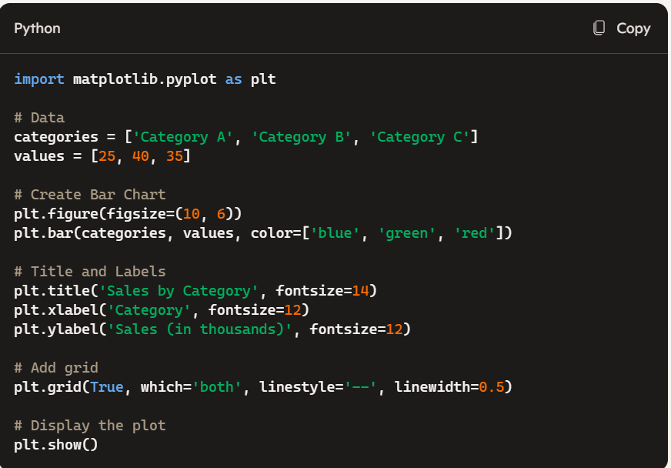

This code snippet creates a bar chart with titles, labels, and a grid for better readability.

**Customization:**

Customization in data visualization is crucial for tailoring your visual representations to effectively communicate your message and cater to your audience. Here are some key areas to consider for customization:

**1. Chart Types**

* **Selecting Appropriate Charts**: Choose the type of chart (bar, line, scatter, etc.) that best represents your data and purpose.

**2. Color Schemes**

* **Consistent Palette**: Use a consistent color scheme that aligns with your brand or theme.
* **Accessibility**: Choose color palettes that are friendly to colorblind users.
* **Contrast**: Ensure sufficient contrast between different elements to improve readability.

**3. Fonts and Typography**

* **Readable Fonts**: Select fonts that are easy to read at various sizes.
* **Consistent Style**: Maintain a consistent font style and size throughout the visualization.
* **Emphasis**: Use bold or italics to highlight important information.

**4. Labels and Annotations**

* **Clear Labels**: Ensure all axes, data points, and legends are clearly labeled.
* **Detailed Annotations**: Add annotations to provide context or explain significant data points.
* **Interactive Elements**: For digital visualizations, consider adding tooltips or hover effects to display additional information.

**5. Data Presentation**

* **Aggregating Data**: Customize how data is aggregated (e.g., monthly, quarterly) to suit your analysis.
* **Grouping and Sorting**: Group and sort data in a way that highlights key patterns or trends.

**6. Axes and Scales**

* **Custom Scales**: Adjust axes scales to best fit the data range.
* **Dual Axes**: Use dual axes if you need to represent two different variables on the same chart.

**7. Interactive Features**

* **Filtering and Slicing**: Allow users to filter or slice data to explore different perspectives.
* **Drill-down Capabilities**: Enable drill-down features to provide deeper insights into the data.

**8. Design Tools and Software**

* **Python Libraries (Matplotlib, Seaborn)**: Allow for extensive customization through coding.
* **Tableau**: Provides a wide range of customization options with a user-friendly interface.
* **Excel**: Offers basic customization features suitable for simple visualizations.

**Example: Customizing a Bar Chart with Matplotlib**

Here’s an example of customizing a bar chart using Python’s Matplotlib library:

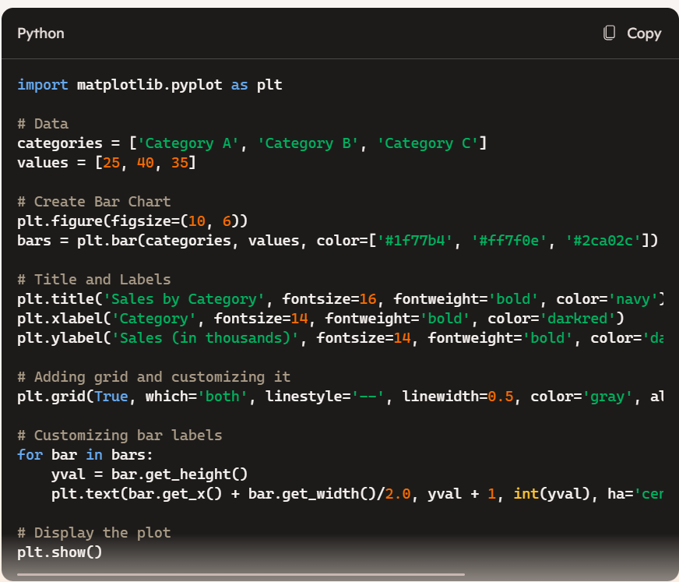

**Data Visualization Through Graph Representations:**

**Data Visualization Through Graph Representations** involves using graphical structures to illustrate relationships and patterns within datasets. Graphs consist of nodes (or vertices) and edges (or links) that connect them. This method is especially powerful for visualizing complex relationships, such as networks, hierarchies, or flow structures.

**Key Concepts:**

1. **Nodes and Edges**:
   * **Nodes** represent entities (e.g., people, cities, computers).
   * **Edges** represent relationships or interactions between nodes (e.g., friendships, roads, data connections).
2. **Types of Graphs**:
   * **Undirected Graphs**: Edges have no direction, implying mutual relationships (e.g., Facebook friends).
   * **Directed Graphs (Digraphs)**: Edges have direction, indicating a one-way relationship (e.g., Twitter followers).
   * **Weighted Graphs**: Edges have weights to signify the strength or cost of relationships (e.g., distances between cities).
   * **Bipartite Graphs**: Two distinct sets of nodes, with edges only between sets (e.g., job applicants and companies).
3. **Graph Layouts**:
   * **Force-Directed Layout**: Nodes repel each other while edges act like springs, balancing the graph visually.
   * **Hierarchical Layout**: Shows layered structures, often used in organizational charts or decision trees.
   * **Circular Layout**: Nodes are arranged in a circle, emphasizing cyclic relationships.
4. **Applications of Graph Visualization**:
   * **Social Networks**: Visualizing relationships and influencers.
   * **Transportation Networks**: Mapping routes and optimizing paths.
   * **Biological Networks**: Understanding protein interactions or neural connections.
   * **Web Graphs**: Mapping how websites link to each other.
5. **Tools for Graph Visualization**:
   * **Gephi**: Open-source software for exploring and visualizing networks.
   * **Graphviz**: Tool for drawing graphs specified in the DOT language.
   * **D3.js**: JavaScript library for producing dynamic, interactive data visualizations.
   * **NetworkX**: Python library for the creation, manipulation, and study of complex networks.
6. **Interpreting Graphs**:
   * **Centrality**: Identifies the most important nodes in a network.
   * **Clustering**: Finds groups of nodes that are more densely connected internally.
   * **Path Analysis**: Shortest paths, connectivity, and flow within the graph.

**High-Dimensional Data Visualization:**

**High-Dimensional Data Visualization** focuses on representing data with many features (dimensions) in a way that can be comprehended visually. Since human perception is limited to 2D or 3D, visualizing data with more than three dimensions requires specialized techniques to reduce dimensionality while preserving patterns, relationships, and structures.

**Challenges in High-Dimensional Data Visualization:**

1. **Curse of Dimensionality**: As dimensions increase, data becomes sparse, and patterns can become harder to detect.
2. **Overlapping Data**: Projecting multiple dimensions into 2D/3D can cause different data points or clusters to overlap, obscuring relationships.
3. **Loss of Information**: Dimensionality reduction techniques can sometimes lead to loss of important data characteristics.

**Techniques for Visualizing High-Dimensional Data:**

1. **Dimensionality Reduction Techniques**:
   * **Principal Component Analysis (PCA)**:
     + A linear technique that transforms data into a new coordinate system where the greatest variances lie on the first axes (principal components).
     + Useful for reducing dimensions while retaining as much variance as possible.
     + **Visualization**: Scatter plots of the first two or three principal components.
   * **t-Distributed Stochastic Neighbor Embedding (t-SNE)**:
     + A non-linear technique particularly good for visualizing complex, high-dimensional datasets (e.g., image data, word embeddings).
     + Preserves local structures, making it excellent for clustering visualization.
     + **Visualization**: 2D scatter plots showing clusters and neighborhoods.
   * **Uniform Manifold Approximation and Projection (UMAP)**:
     + Similar to t-SNE but often faster and better at preserving both local and global structures.
     + **Visualization**: Produces scatter plots like t-SNE but may handle larger datasets more effectively.
   * **Autoencoders**:
     + Neural networks trained to compress data into a lower-dimensional latent space and then reconstruct it.
     + The latent space can be visualized for insights into the structure of the data.
2. **Parallel Coordinates**:
   * Each axis represents a dimension, and data points are shown as lines crossing through these axes.
   * Useful for identifying patterns, correlations, and outliers across dimensions.
3. **Radial (or Star) Plots**:
   * Each dimension radiates from a central point, and data points are plotted as polygons connecting the axes.
   * Good for comparing multiple variables simultaneously.
4. **Heatmaps**:
   * Visualizes data matrices where colors represent the magnitude of values.
   * Useful for showing correlations or feature importance.
5. **Pair Plots (Scatterplot Matrices)**:
   * Generates scatter plots for every possible pair of dimensions.
   * Useful for small-to-medium datasets to identify pairwise relationships.

**Popular Tools and Libraries:**

1. **Python Libraries**:
   * **Matplotlib & Seaborn**: For basic plotting, pair plots, and heatmaps.
   * **Scikit-learn**: Implements PCA, t-SNE, and other dimensionality reduction techniques.
   * **Plotly**: For interactive 3D and high-dimensional visualizations.
   * **UMAP-learn**: For UMAP-based dimensionality reduction.
2. **R Libraries**:
   * **ggplot2**: For general-purpose plotting and extensions like ggpairs for pair plots.
   * **plotly**: For interactive and 3D plots.
3. **Interactive Tools**:
   * **Tableau**: Visual analytics tool that can handle multidimensional data.
   * **Power BI**: Microsoft’s data visualization platform with support for high-dimensional data.

**Applications of High-Dimensional Data Visualization:**

1. **Genomics & Bioinformatics**: Analyzing gene expression data across many conditions.
2. **Finance**: Visualizing portfolios with multiple assets and risk factors.
3. **Image & Text Analysis**: Reducing the dimensionality of embeddings from models like Word2Vec or deep learning features.
4. **Marketing & Customer Segmentation**: Understanding customer behavior across various features.
5. **Anomaly Detection**: Identifying outliers in datasets with many variables.

**Linked Data Views:**

**Linked Data Views** in data visualization refer to interactive visualizations where multiple views (charts, graphs, maps, etc.) are connected. When a user interacts with one view—such as selecting a data point or filtering a range—other views update accordingly to reflect that interaction. This approach is particularly useful for exploring complex datasets from different perspectives simultaneously.

**Key Concepts of Linked Data Views:**

1. **Coordination of Multiple Views**:
   * Different visualizations (e.g., scatter plots, bar charts, and maps) are displayed side by side.
   * User actions in one view (like selecting, filtering, or hovering over data) affect the display of other views.
2. **Brushing and Linking**:
   * **Brushing**: The act of selecting data points in one view.
   * **Linking**: Automatically highlighting or updating corresponding data in other views.
   * Example: Selecting a cluster in a scatter plot highlights corresponding bars in a histogram.
3. **Cross-Filtering**:
   * Filters applied in one view dynamically adjust the data displayed in other views.
   * Example: Filtering a time range in a line chart updates a related pie chart showing categorical distribution for that period.
4. **Synchronized Zooming and Panning**:
   * Zooming or panning in one visualization leads to synchronized changes in related visualizations.
   * Example: Zooming into a geographical region on a map updates a time series chart to show data from that specific area.

**Benefits of Linked Data Views:**

* **Enhanced Data Exploration**: Users can uncover relationships and patterns across different dimensions of the data.
* **Contextual Analysis**: Provides multiple perspectives of the same dataset, helping to contextualize findings.
* **Improved User Interaction**: Makes the visualization more interactive and intuitive, supporting better decision-making.
* **Facilitates Storytelling**: Different views work together to tell a cohesive story about the data.

**Examples of Linked Data Views:**

1. **Sales Dashboard**:
   * A bar chart shows monthly sales, a pie chart shows product category distribution, and a map displays sales by region.
   * Selecting a month in the bar chart updates both the pie chart and the map to reflect that month's data.
2. **Geospatial Data Analysis**:
   * A map view displays locations of interest, while a histogram shows frequency distributions and a table lists detailed attributes.
   * Clicking a location on the map highlights its corresponding row in the table and updates the histogram.
3. **Customer Segmentation**:
   * A scatter plot shows customer clusters based on behavior, and a table lists demographic details.
   * Selecting a cluster updates the table to show only the customers in that segment.

**Tools and Libraries for Linked Data Views:**

1. **Web-Based Visualization Libraries**:
   * **D3.js**: Provides the flexibility to create custom linked visualizations, though it requires more coding effort.
   * **Plotly**: Simplifies the creation of interactive linked views with built-in support for brushing and linking.
   * **Vega & Vega-Lite**: High-level grammar of interactive graphics, allowing for easy creation of linked visualizations.
2. **Dashboard Tools**:
   * **Tableau**: Offers robust features for linking visualizations through filters and actions.
   * **Power BI**: Provides drag-and-drop functionality to create linked views and cross-filtering.
   * **Google Data Studio**: Enables basic linking between charts for interactive dashboards.
3. **Python Libraries**:
   * **Dash (by Plotly)**: A Python framework for building interactive web applications with linked visualizations.
   * **Bokeh**: Provides interactivity and linking capabilities for visualizations in Python.
   * **Altair**: Built on Vega-Lite, it allows easy creation of linked views with concise code.
4. **R Libraries**:
   * **Shiny**: Builds interactive web applications in R, supporting linked visualizations.
   * **ggplot2 + plotly**: Combine for creating static ggplot visualizations with added interactivity using Plotly.

**Applications of Linked Data Views:**

1. **Business Intelligence**: Interactive dashboards for tracking KPIs, sales performance, and customer behavior.
2. **Healthcare Analytics**: Linking patient demographics, medical history, and treatment outcomes.
3. **Scientific Research**: Exploring complex datasets like genomic data, climate models, or physics simulations.
4. **Finance**: Visualizing market trends, portfolio performance, and risk analysis from multiple perspectives.
5. **Urban Planning**: Linking geographic maps with demographic statistics and environmental data.